**Step to be followed by the user while registering for the Lab:**

1. Open the Bit.ly URL provided by the instructor and fill the details and submit the registration Form.

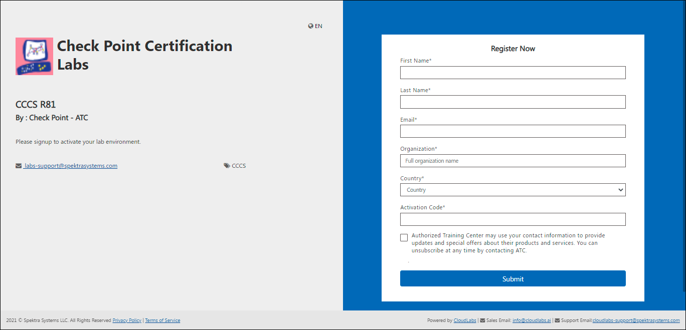

1. Once the user submits registration form, they will be able to see the Azure and AWS Environments.

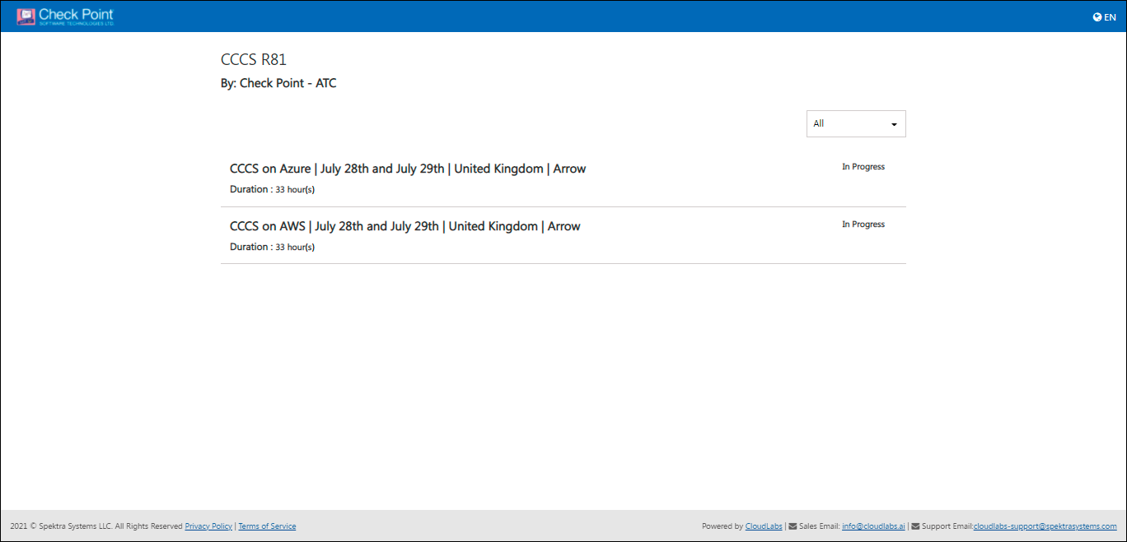

1. User can click on the first lab and once the user clicks on the lab, another tab will be opened with the launch lab button, the user can click on the launch lab button and the lab environment will be provisioned in a couple of minutes.

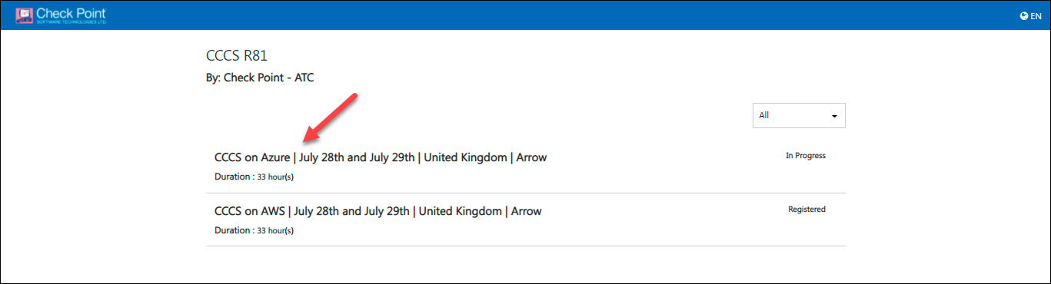

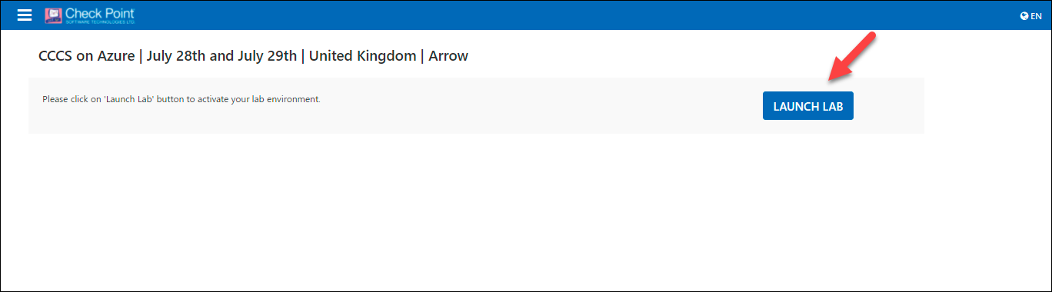

1. The user can now login to the Jump VM using the **VM DNS Name**, **VM Admin Username**, and **VM Admin Password**. The user can later use the provided “Username” and “Password” to login to Azure Portal.

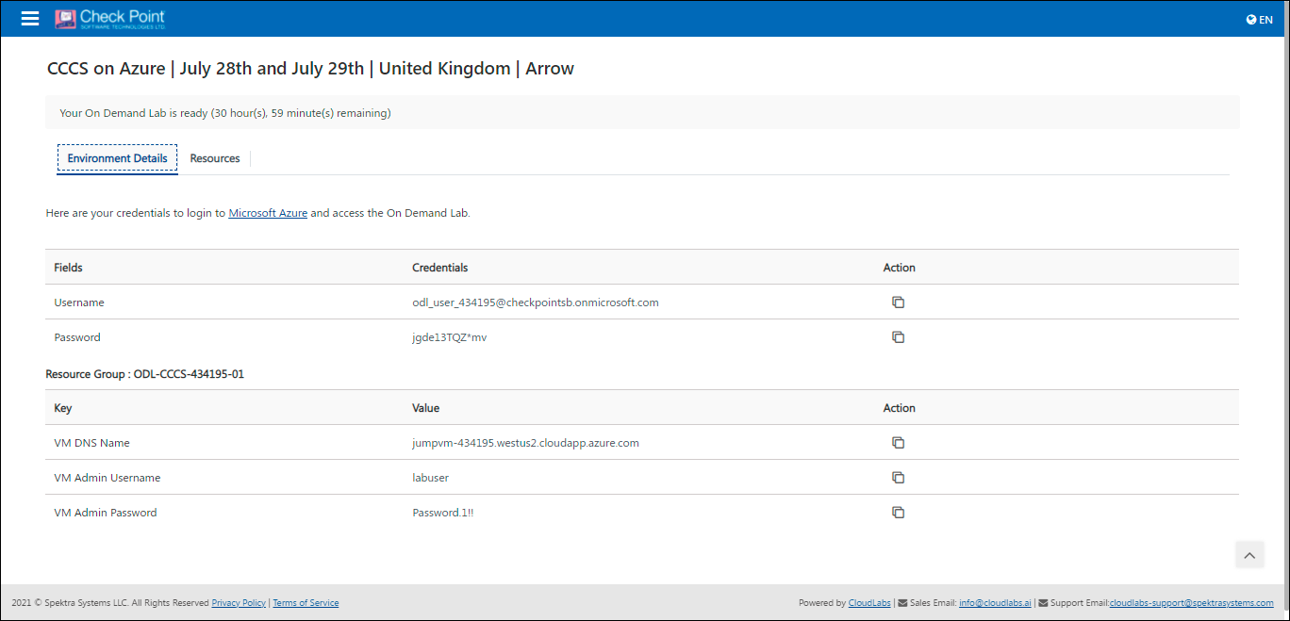

1. Once the user is done with the current lab he can go back to the previous tab and select the next lab in the list to directly launch the lab.

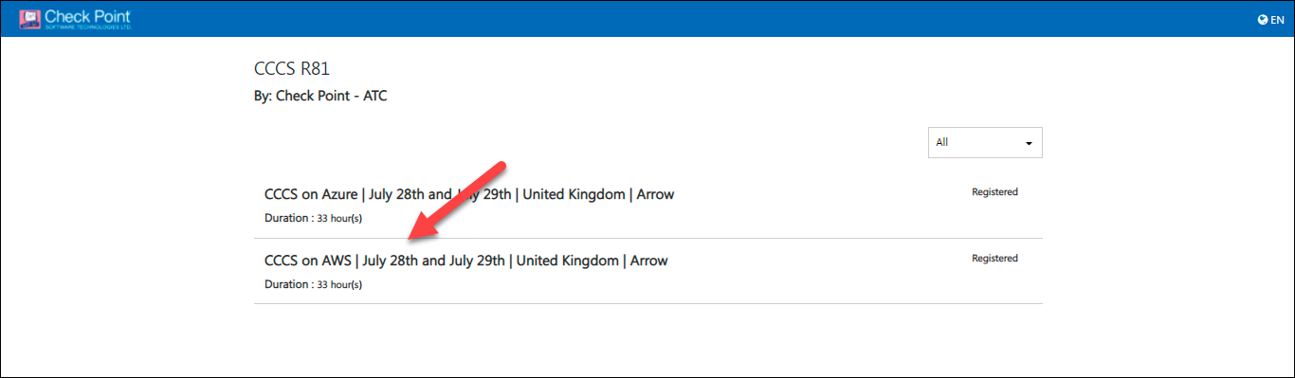

1. The user can now use the **Sign-in link**, **Username**, and **Password** to login to the AWS Environment.

